The Music of the Golden Triangle
and The Cycles of Life
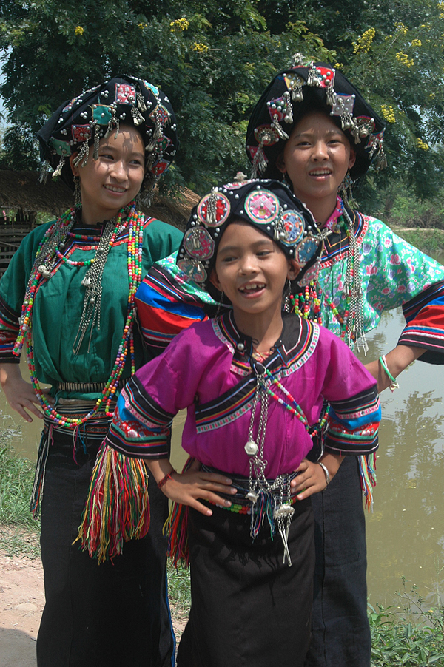
Victoria Vorreiter is a professional musician and documentary filmmaker based in Chiang Mai, who has spent the last 5 years trekking to remote villages in Laos, Myanmar/Burma, China, and Thailand to document the traditional songs and ceremonies of the mountain peoples. Since 2005 she has amassed a vast and varied archive of films, recordings, photos, and journals, which chronicle traditions that are quickly, quietly vanishing. To complement this living body of work, she has also assembled complete collections of musical instruments and traditional clothing of 6 of the major tribal groups in the Golden Triangle.

By producing documentation through diverse media, all of which interrelate, she will be creating an archival project that is one of the most complete and integrative ever on the subject of tribal culture of Southeast Asia.

Documentary Film
The Music of the Golden Triangle and the Cycles of Life Film, a one-hour documentary film formatted for public television, bears witness to the ancestral songs and ceremonies of many of the 130 different tribal peoples who inhabit the mountains of the Golden Triangle.
Filmed over three years in remote hill villages of Laos, Myanmar/Burma, Thailand, and China, the film follows cycles of the earth and passages of life to illustrate a remarkable spectrum of traditional music and rites that infuse daily and sacred experiences.
The Music of the Golden Triangle Film moves from infancy to old age, highlighting ceremonies rarely witnessed: fertility festival, safe birth ceremony, baby naming, courting and marriage, harvest festival, New Year festival, ancestor worship, healing rites, and funerals. (Documentary Film will be completed in 2012)

Educational Films
The Music of the Golden Triangle Educational Films is a series of 20-25 in-depth one-hour documentaries based on individual tribal groups, which capture a single ceremony in its entirety. Traditional peoples of Southeast Asia honor their ancestors and spirits with complex, highly organized rituals that last many hours, often many days. The Educational Films offer the essence of these celebrations in a condensed format. Each will feature extended footage of music, rituals and other aspects of traditional daily village life.
The Educational Films include an informational narrative and full translations, and are created for the general public as well as scholars, researchers, anthropologists and ethnomusicologists. Additionally, educators in such diverse fields as sociology, religion, folk arts, folklore, cultural geography and ethnic studies may utilize these Educational Films to engage students from grade school to the university level. The series can be experienced as a whole or each film can be viewed independently.
For descendants of the ethnic groups portrayed–some who may have moved away from their ancestral villages, perhaps to another country–these documentaries will serve as a source of identity, preserving rituals and music for future generations. (Educational Films will be completed in 2012)

Book
Songs of Memory: Traditional Music of the Golden Triangle, a revealing and richly illustrated book, explores the cultural and musical foundations of the Akha, Lahu, Lisu, Hmong, Mien, and Karen, six distinct groups who have maintained their independence and identity to a high degree. The book displays musical practices that animate daily and sacred life through field photographs of musicians and ceremonies rarely witnessed, as well as detailed galleries of the musical instruments of each group. (Resonance Press, April 2009. 200 pages, over 400 color photographs, 10.75" x 9" / 27.6 x 23.3 cm, ISBN: 978 - 0 - 692 - 00262 – 9)

Music Recordings
The Songs of Memory CD, a sampler audio collection released in 2009, highlights the traditional music of the Karen, Hmong, Mien, Lahu, Akha, and Lisu, six tribal groups found in the highlands of Laos, Myanmar, Thailand, and China.
Traditional peoples have kept their culture alive for millennia through ancestral songs, sacred chants, and musical instruments. Yet each group represents an exceptional musical legacy, unique not only in melody and rhythm, but also in signature style. Collectively these cultures make the Golden Triangle one of the most musically diverse places on the planet. (39 musical selections, 78 minutes)

Exhibition
Through an extensive collection of musical instruments and clothing, documentary films and photographs of rarely seen rituals, the Songs of Memory Exhibition explores the ancestral ceremonies of the mountain peoples of Southeast Asia. The Karen, Hmong, Mien, Lahu, Akha, and Lisu have passed on their knowledge from generation to generation through oral tradition. This multi-media exhibition highlights the rich diversity of these traditional peoples by showcasing their musical heritage, a vivid testament to the integrity and beauty of their unique cultures.
It is intended that this ‘traveling exhibition’ move to other museums in Thailand, SE Asia, and around the world, for an international community to appreciate.

Foundation and Museum
The Resonance Project has plans to develop a Foundation that will oversee a permanent Museum to house the exhibition collections and a Research Center whose mission is to collect, record, and archive traditional tribal music of SE Asia.
The Center will host dynamic symposiums between learned tribal elders, academics, and experts in a variety of fields to exchange information and to explore further ways to preserve and document tribal traditions. Furthermore it is hoped that these discussions, demonstrations, and concerts will help bridge understanding about the extraordinary cultures of northern Thailand.

News and Events:
In the past year the Music of the Golden Triangle project has leapt from the jungle into the bigger world with a series of high profile events:

Songs of Memory: Traditional Music of the Golden Triangle
Multi-media Exhibition of Instruments, Clothing, Music and Films
of the Karen, Hmong, Mien, Lahu, Akha, and Lisu peoples
Curated by Victoria Vorreiter
The Jim Thompson Arts Center, Bangkok, Thailand
23 April – 23 July 2009

Photo Exhibition: People with Hats
Book Launch: Songs of Memory
Curated and Designed by Victoria Vorreiter
Suriwong Book Centre, Chiang Mai, Thailand
1 - 15 November 2009

Photo Exhibition: Patterns, Passages & Prayers
Tamarind Village Resort, Chiang Mai, Thailand
Curated by Victoria Vorreiter
21 December 2009 - 31 July 2010

Songs of Memory: Traditional Music of the Golden Triangle
Multi-media Exhibition of Instruments, Clothing, Music, Photos and Films
of the Karen, Hmong, Mien, Lahu, Akha, and Lisu peoples
Curated and Designed by Victoria Vorreiter

Tribal Wisdom Symposium: Sharing and Preserving Traditional Knowledge
A Symposium of Tribal Culture, History, and Beliefs
Featuring Lectures, Discussions, Arts Demonstrations, Concerts, Food Festival
Chiang Mai Arts and Cultural Center, Chiang Mai, Thailand
12 February – 30 April 2010

Victoria Vorreiter
www.tribalmusicasia.com
vvorreiter@yahoo.com

