Victoria Vorreiter
Director and Producer
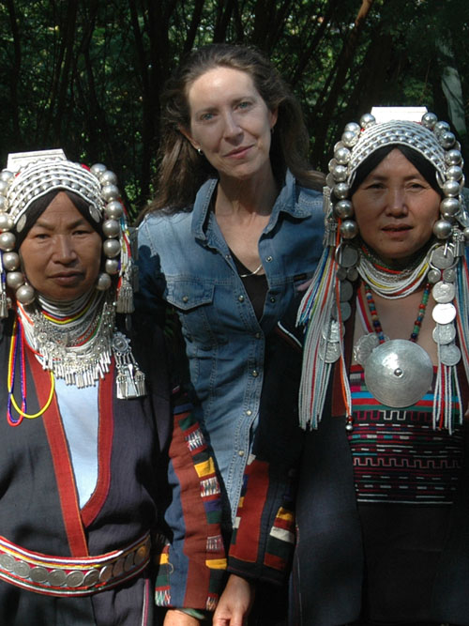
Victoria Vorreiter is a classical violinist and formerly a faculty member of the DePaul University School of Music in Chicago, Illinois. Her degrees include a Bachelor and Master of Music, and a Master of Arts and Liberal Studies. A specialist in the Suzuki Method of music instruction, Victoria has been invited to present at conferences as a guest lecturer and clinician around the globe.

In recent years, Victoria, whose work is best described as creating a “cultural Noah’s Ark,” has turned her eye to documenting world music. During a 1998 visit to Morocco she witnessed the primal role that music plays in the lives of traditional peoples, who maintain a vital oral tradition that is thousands of years old. This experience compelled her to create The Resonance Project in 2000, a nonprofit organization that creates a series of independent documentary films formatted for public television, Music and the Cycles of Life, providing a vivid testament to cultural observances and values around the world.

The Music of Morocco and the Cycles of Life is the result of Victoria’s travels in Morocco, from the Mediterranean Sea to the Sahara Desert, from the High Atlas Mountains to the fertile valleys, from the great Imperial cities to small Berber villages. Since its release in 2002 the film has been screened on three continents at cultural organizations, museums, film festivals, schools and universities, including such venues as the National Geographic Society, the Smithsonian Institute, and the Anfa Cultural Center in Casablanca, Morocco.

In 2004 Victoria made Chiang Mai, Thailand, her home, and began trekking solo to remote villages high in the mountains of Thailand, Laos, Myanmar, and China to document the music and the rites of passage among the hill tribes. Her vision for The Music of the Golden Triangle and the Cycles of Life grew in the following years to include complementary media: Educational Films, a Songs of Memory book and CD as well as a Songs of Memory Exhibition, which was first launched at the prestigious Jim Thompson Art Centre in Bangkok. A permanent Museum and Research Center is planned to help preserve the vocal and instrumental heritage of the mountain peoples; to show the world the integrity, wisdom, and beauty of the traditional cultures of SE Asia; and to serve as a bridge for mutual understanding among all peoples.

"Indigenous peoples in these inaccessible hills have depended for millennia on oral tradition to transmit knowledge, history, and beliefs. How long these time-honored customs can continue, with the encroachment of 21st century technology, is in doubt. The aim of my work is to help preserve the majesty of these tribal rituals before they disappear.” Victoria Vorreiter

